EJC EXAMPLE 1
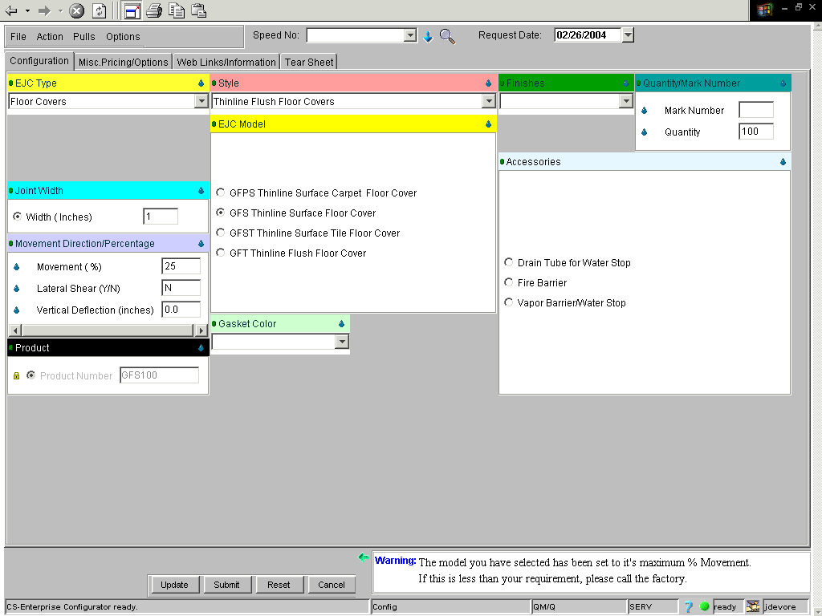
If done correctly, your price will equal $808.00.

Reminder: The box indicating a Warning in the lower right corner is a guide on required inputs.

